|  |  |
| --- | --- |
|  |  |



**Course Title: Mining and Analyzing Software Repositories**

**Assignment – 3**

**(Week – 5)**

**Instructor: Dr. Mariam Akbar**

**Submitted by:**

**Engr. Nabeel Ahmed**

**CIIT-SP23-RSE-012/ISB**

|  |
| --- |
| **Department of Computer Science COMSATS University Islamabad**  **Department of Computer Science** |

**www.comsats.edu.pk**

**Ensemble Learning Techniques**

**Date-set**

I have used the following dataset of Carbon Emissions.

https://www.kaggle.com/datasets/abdelrahman16/co2-emissions-usa/data

**Code**

See the following GitHub repository.

https://github.com/Metaverse-Nabeel/Ensemble-Learning-Techniques

**Results**

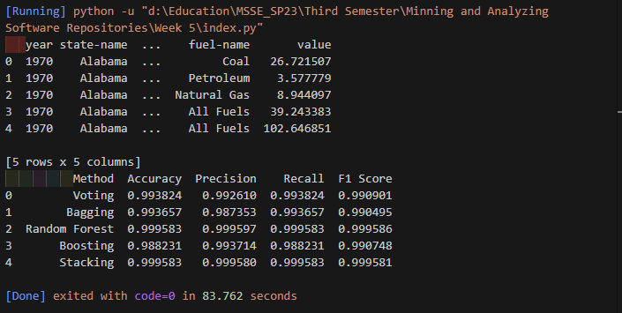

**Steps to Execute**

1. Clone the repository:

https://github.com/Metaverse-Nabeel/Ensemble-Learning-Techniques

1. Run the python script using VS Code or any editor of your choice.
2. After few seconds the results will be shown in the terminal.